Structural equation models: first practical approach
2025-01-14

Example
We want to predict the intelligence of children by the intelligence of their mothers and their age.
- Display the model graphically and write down the model equation.
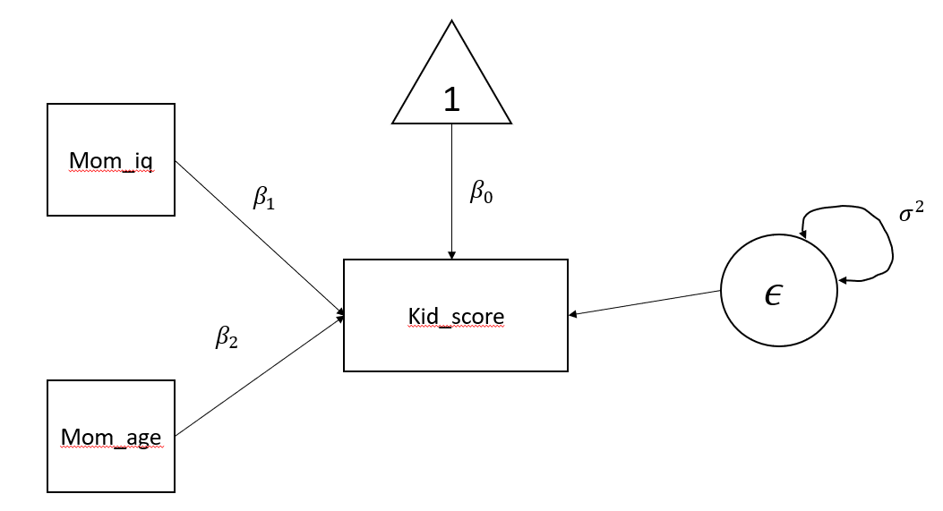
Model 1
- What type of model is represented?
Multiple linear regression model
- Which parameters belong to the covariance structure and which to the mean value structure?
$β_{0}$ is the parameter for the mean value structure; $β_{1}$, $β_{2}$ and $σ^{2}$ are the parameters for the covariance structure.
- What variables are endogenous and which are exogenous?
Mom_IQ and Mom_Age are the exogenous variable; Kid_Score is the endogenous variable.
- What are the latent variables and what are the observed variables?
There are 3 observed variables and 1 latent variable
- what kind of link is assumed between the Mom_age and the kid_score?
Directed arrow (regressive effect)
- What is the coefficient of the error component?
1
Load the data set iqkind from the R data file iqkind.Rdata.
library(lavaan)
## Warning: package 'lavaan' was built under R version 4.3.3
## This is lavaan 0.6-17
## lavaan is FREE software! Please report any bugs.
load(url("http://jastag.org/data/iqkind.Rdata"))
str(iqkind)
## 'data.frame': 434 obs. of 3 variables:
## $ kid_score: int 65 98 85 83 115 98 69 106 102 95 ...
## $ mom_iq : num 121.1 89.4 115.4 99.4 92.7 ...
## $ mom_age : int 27 25 27 25 27 18 20 23 24 19 ...
- Estimate the model with lavaan
# lavaan syntax
mod <- '#regression part
kid_score ~ 1 + mom_iq + mom_age
# variance part
kid_score ~~ kid_score'
#Model estimation with lavaan
#fit <- lavaan(mod,iqkind)
fit <- sem(mod,iqkind)
#Display results
summary(fit,rsquare=TRUE)
## lavaan 0.6.17 ended normally after 1 iteration
##
## Estimator ML
## Optimization method NLMINB
## Number of model parameters 4
##
## Number of observations 434
##
## Model Test User Model:
##
## Test statistic 0.000
## Degrees of freedom 0
##
## Parameter Estimates:
##
## Standard errors Standard
## Information Expected
## Information saturated (h1) model Structured
##
## Regressions:
## Estimate Std.Err z-value P(>|z|)
## kid_score ~
## mom_iq 0.604 0.059 10.311 0.000
## mom_age 0.388 0.325 1.194 0.232
##
## Intercepts:
## Estimate Std.Err z-value P(>|z|)
## .kid_score 17.596 9.053 1.944 0.052
##
## Variances:
## Estimate Std.Err z-value P(>|z|)
## .kid_score 331.026 22.472 14.731 0.000
##
## R-Square:
## Estimate
## kid_score 0.204
- Compare the following output with the one obtained by lm() function.
res <- lm(kid_score ~ mom_iq + mom_age,iqkind)
summary(res)
##
## Call:
## lm(formula = kid_score ~ mom_iq + mom_age, data = iqkind)
##
## Residuals:
## Min 1Q Median 3Q Max
## -56.941 -12.493 2.257 11.614 46.711
##
## Coefficients:
## Estimate Std. Error t value Pr(>|t|)
## (Intercept) 17.59625 9.08397 1.937 0.0534 .
## mom_iq 0.60357 0.05874 10.275 <2e-16 ***
## mom_age 0.38813 0.32620 1.190 0.2348
## ---
## Signif. codes: 0 '***' 0.001 '**' 0.01 '*' 0.05 '.' 0.1 ' ' 1
##
## Residual standard error: 18.26 on 431 degrees of freedom
## Multiple R-squared: 0.2036, Adjusted R-squared: 0.1999
## F-statistic: 55.08 on 2 and 431 DF, p-value: < 2.2e-16
- Specify the value of $β_{0}$ (or $α$), $β_{1}$, $β_{2}$ and $σ^{2}$.
$β_{0}=17.596$, $β_{1}=0.604$, $β_{2}=0.388$ and $σ^{2}=331.026$.
- Write the final equation of the model using the estimated parameter.
$kidScore=17.596+0.604momIq+0.388momAge+ϵ$ $ϵ∼N\left(0,331.026\right)$
- Provide an interpretation about the regression coefficients.
If mom_iq remains constant, and mom_age increases by one unit, the predicted kid_score is expected to increase by 0.388 units.

Exercise 1
We want to investigate if the subjects’ age (age) and cigarettes smoked per day (cigday) are predictive of motivation to quit smoking (MQS).
load("C:/Users/freulif/Desktop/Lezioni2025/SEM1/dataset/electrosmoke.rda")
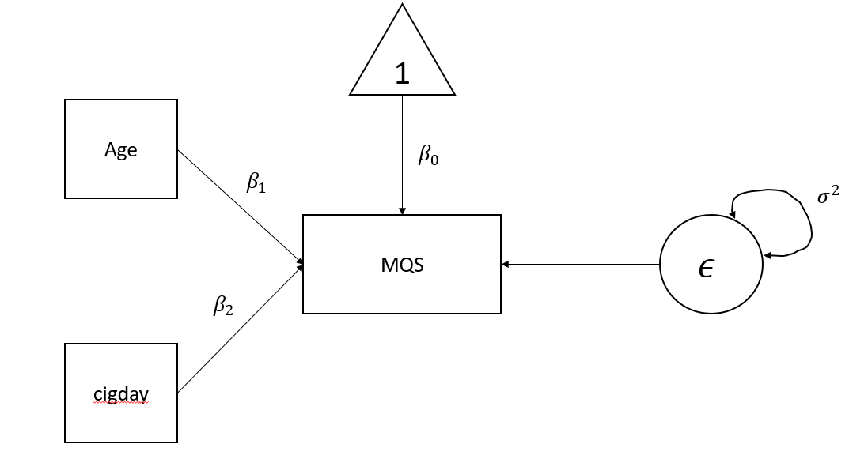
Model 2
- What type of model is represented?
Multiple regression model with two predictors and one dependent variable.
- Which parameters belong to the covariance structure and which to the mean value structure?
covariance structure = $β_{1}$, $β_{2}$ and $σ^{2}$
- Which variables are endogenous and which are exogenous?
Age and SigDay are exogenous while MQS is endogenous.
- What are the equations of the model?
$$y=β_{0}+β_{1}Age+β_{2}cigday+ϵ$$
$$ϵ∼N\left(0,σ^{2}\right)$$
- What are the latent variables and what are the observed variables?
There are three observed (manifested) variable and one latent variable.
- What kind of link is assumed between the Age and the MQS?
regressive effect
- What is the coefficient of the intercept?
$β_{0}$
- Estimate the model with lavaan.
mod <- 'MQS ~ 1+ age + cigday
MQS ~~ MQS'
fit <- sem(mod,electrosmoke)
summary(fit, rsquar=T)
## lavaan 0.6.17 ended normally after 1 iteration
##
## Estimator ML
## Optimization method NLMINB
## Number of model parameters 4
##
## Number of observations 258
##
## Model Test User Model:
##
## Test statistic 0.000
## Degrees of freedom 0
##
## Parameter Estimates:
##
## Standard errors Standard
## Information Expected
## Information saturated (h1) model Structured
##
## Regressions:
## Estimate Std.Err z-value P(>|z|)
## MQS ~
## age 0.092 0.020 4.508 0.000
## cigday 0.008 0.015 0.547 0.584
##
## Intercepts:
## Estimate Std.Err z-value P(>|z|)
## .MQS 12.363 0.942 13.122 0.000
##
## Variances:
## Estimate Std.Err z-value P(>|z|)
## .MQS 5.315 0.468 11.358 0.000
##
## R-Square:
## Estimate
## MQS 0.074
- Compare the following output with the one obtained by lm() function.
res <- lm(MQS ~ age + cigday,electrosmoke)
summary(res)
##
## Call:
## lm(formula = MQS ~ age + cigday, data = electrosmoke)
##
## Residuals:
## Min 1Q Median 3Q Max
## -4.9799 -1.5765 -0.2997 1.1605 8.4050
##
## Coefficients:
## Estimate Std. Error t value Pr(>|t|)
## (Intercept) 12.363005 0.947687 13.045 < 2e-16 ***
## age 0.091744 0.020473 4.481 1.12e-05 ***
## cigday 0.008199 0.015081 0.544 0.587
## ---
## Signif. codes: 0 '***' 0.001 '**' 0.01 '*' 0.05 '.' 0.1 ' ' 1
##
## Residual standard error: 2.319 on 255 degrees of freedom
## Multiple R-squared: 0.07375, Adjusted R-squared: 0.06649
## F-statistic: 10.15 on 2 and 255 DF, p-value: 5.726e-05
- Specify the value of $β_{0}$ (or $α$), $β_{1}$, $β_{2}$ and $σ^{2}$.
$β_{0}=12.363$, $β_{1}=0.092$, $β_{2}=0.008$ and $σ^{2}=5.315$
- Write the final equation of the model using the estimated parameter.
$$MQS=12.363+0.092Age+0.008cigday+ϵ$$
$$ϵ∼N\left(0,5.315\right)$$
- Provide an interpretation about the regression coefficients.
If age remains constant, and cigday increases by one unit, the predicted MQS is expected to increase by 0.008 units.
If cigday remains constant, and age increases by one unit, the predicted MQS is expected to increase by 0.092 units.

Exercise 2
A researcher wants to investigate if adolescent substance use can be predicted by socio-economic status, family environment and parental substance use. The results are stored in the SubstanceUse.Rdata file.
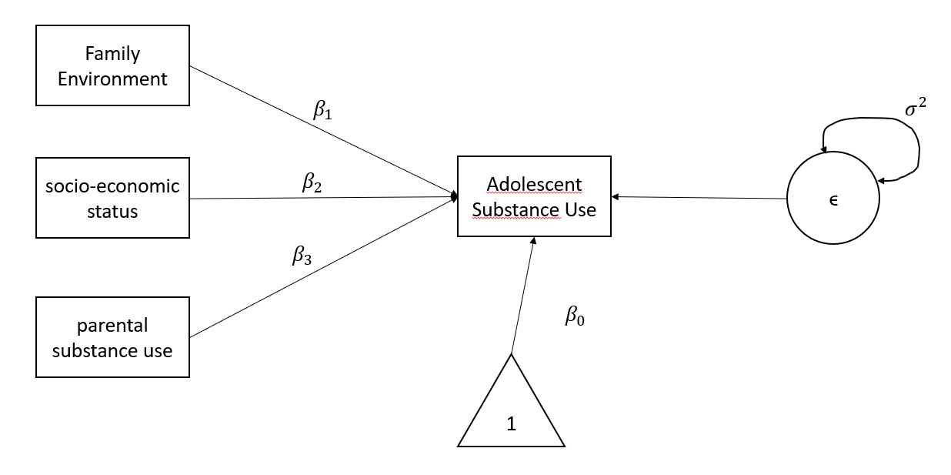
Model 3
- How many endogenous and how many exogenous variables are present in the model?
one endogenous variable and three exogenous variables.
- What are the equations of the model?
$$y=β_{0}+β_{1}FamilyEnvironment+β_{2}Socio−economicStatus+β_{3}ParentalSubUse+ϵ$$
$$ϵ∼N\left(0,σ^{2}\right)$$
- What does the $σ^{2}$ parameter denote?
$σ^{2}$ is the variance of the error component.
- How many coefficients must the model estimate?
The model has to estimate 4 coefficients and 5 parameters
- Which parameters belong to the covariance structure and which to the mean value structure?
covariance structure = $β_{1}$, $β_{2}$, $β_{3}$ and $σ^{2}$
mean structure = $β_{0}$
- Estimate the model with lavaan.
load("C:/Users/freulif/Desktop/Lezioni2025/SEM1/dataset/SubstanceUse.Rdata")
mod <- 'Adolescent_Substance ~ 1+ SocioEconomic_status + Family_Environment+
Family_Environment+Parental_Substance
Adolescent_Substance ~~ Adolescent_Substance'
res <- sem(mod,data)
summary(res,rsquar = TRUE)
## lavaan 0.6.17 ended normally after 1 iteration
##
## Estimator ML
## Optimization method NLMINB
## Number of model parameters 5
##
## Number of observations 100
##
## Model Test User Model:
##
## Test statistic 0.000
## Degrees of freedom 0
##
## Parameter Estimates:
##
## Standard errors Standard
## Information Expected
## Information saturated (h1) model Structured
##
## Regressions:
## Estimate Std.Err z-value P(>|z|)
## Adolescent_Substance ~
## SociEcnmc_stts 0.197 0.042 4.675 0.000
## Famly_Envrnmnt -0.118 0.070 -1.695 0.090
## Parentl_Sbstnc 0.057 0.048 1.194 0.233
##
## Intercepts:
## Estimate Std.Err z-value P(>|z|)
## .Adlscnt_Sbstnc 22.710 2.146 10.582 0.000
##
## Variances:
## Estimate Std.Err z-value P(>|z|)
## .Adlscnt_Sbstnc 0.772 0.109 7.071 0.000
##
## R-Square:
## Estimate
## Adlscnt_Sbstnc 0.208
- Specify the value of $β_{0}$ (or $α$), $β_{1}$, $β_{2}$, $β_{3}$, and $σ^{2}$.
$β_{0}=22.710$; $β_{1}=0.197$, $β_{2}=−0.118$, $β_{3}=0.057$, and $σ^{2}=0.772$
- Write the final equation of the model using the estimated parameter.
$Adolescent_{S}ubstance=22.710+0.197*SocioEconomic_{s}tatus+−0.118*Famly_{E}nvrnmnt+0.057*Parentl_{S}bstnc+ϵ$ with $ϵ∼N\left(0,0.772\right)$
- Provide an interpretation about all regression coefficients.
Keeping all other predictors constant, if SocioEconomic_status increases by one unit, the Adolescent_Substance is expected to increase by 0.197 units.
Keeping all other predictors constant, if Famly_Envrnmnt increases by one unit, the Adolescent_Substance is expected to decrease by -0.118 units.
Keeping all other predictors constant, if Parentl_Sbstnc increases by one unit, the Adolescent_Substance is expected to increase by 0.057 units.

Exercise 3
A researcher wants to investigate if the level of education and gender can predict gross salary. To conduct the study, they recruit a sample of $n$ individuals, representing various genders and educational levels. For each participant, the researcher records their monthly gross salary.
load("C:/Users/freulif/Desktop/Lezioni2025/SEM1/dataset/salary.RData")
- Estimate the model using the lavaan syntax.
mod <- 'SALARY ~ 1 + EDUCATION + SEX
SALARY~~SALARY'
res <- sem(mod,d)
summary(res,rsquare=T)
## lavaan 0.6.17 ended normally after 1 iteration
##
## Estimator ML
## Optimization method NLMINB
## Number of model parameters 4
##
## Number of observations 62
##
## Model Test User Model:
##
## Test statistic 0.000
## Degrees of freedom 0
##
## Parameter Estimates:
##
## Standard errors Standard
## Information Expected
## Information saturated (h1) model Structured
##
## Regressions:
## Estimate Std.Err z-value P(>|z|)
## SALARY ~
## EDUCATION 0.001 0.160 0.003 0.997
## SEX 0.390 0.243 1.605 0.108
##
## Intercepts:
## Estimate Std.Err z-value P(>|z|)
## .SALARY 5.260 0.338 15.559 0.000
##
## Variances:
## Estimate Std.Err z-value P(>|z|)
## .SALARY 0.889 0.160 5.568 0.000
##
## R-Square:
## Estimate
## SALARY 0.040
- Determine the value of the coefficient of determination $R^{2}$ and provide an interpretation.
The coefficient of determination $R^{2}$ is 0.040. Approximately 4% of the total variance in the dependent variable is explained by the independent variables.
3 Determine the value of the intercept.
$β_{0}=5.260$
- What is the value of the parameter $σ^{2}$?
$σ^{2}=0.889$

